Names: Honors Chemistry
Section: Pairs Check: liquids and solutions

Directions:
- Put both names on the paper.
- The older partner does the even problems. The younger partner does the odd problems. Take turns answering the questions. As you work, explain how you are doing the problem while your partner listens.
- After each problem, discuss the answer with your partner. If both partners agree on the answer, the solver initials the answer. If an agreement can’t be reached, both partners raise their hands to get the teacher’s attention.
- Complete the self-assessment and sign both papers.

- Determine the percent by mass of solute if 54.0 g of AgNO₃ are dissolved in a 182 g solution.

- How much water should be added to 7.56 g of MgCl₂ to prepare a .27m solution?

- What is the molality of a solution containing 8.56 g CCl₄ in 156 g benzene?

- What mass of NH₄Cl must be used to prepare 775 mL of a .46M solution?

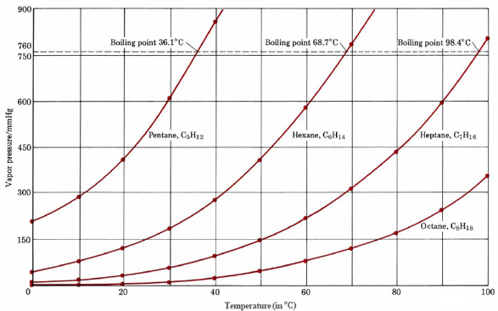

Consider the vapor pressure curves shown on the left.

- At what temperature will pentane boil if the atmospheric pressure is 600 mm Hg?

- What must the atmospheric pressure be in order to cause heptane to boil at 85ºC?

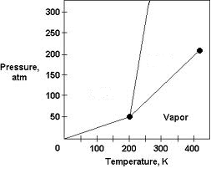Consider the phase diagram shown on the left.
- At what temperature and pressure do all three phases coexist?

- What is the critical pressure of this substance?

Refer to the solubility curves shown on the left to answer the next two questions.

- At 65ºC, how much ammonium chloride can be dissolved in 400 g of water?

- 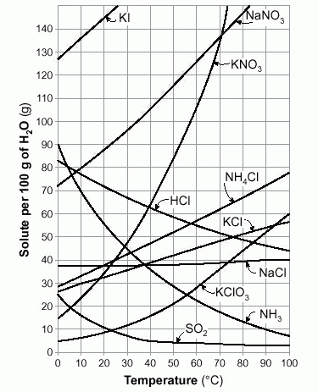A saturated solution of potassium nitrate is formed from 100 g of water. If the saturated solution is cooled from 70ºC to 30ºC, how many grams of precipitate are formed?

- 75 mL of a 0.46M solution of LiCl are diluted to a final volume of 270 mL. What is the final concentration of the diluted solution?

- Which of the following solutions would have the lowest freezing point? The lowest boiling point? Explain how you arrived at your answers. 0.1M C₁₂H₂₂O₁₁, 0.1 M NaCl, 0.1M K₃PO₄

- What is the new freezing point if 21.2 g of CaCl₂ is dissolved in 775 g of water?
k_{B} for water = 0.52 ºC/m
k_{F} for water = 1.86 ºC/m

- When 3.5 g of a nonelectrolyte is added to 85 grams of water, the new boiling point is 103.4ºC. What is the gram formula mass of the unknown compound?

The purpose of this assignment was to: ____________________________________________________________________________________

____________________________________________________________________________________

Did I: | Circle the appropriate response:
Explain how I did the problems? | Always Sometimes Rarely
Listen while my partner explained? | Always Sometimes Rarely
Give my partner positive support? | Always Sometimes Rarely
Stay on task during the assignment? | Always Sometimes Rarely
Use encouraging and polite words? | Always Sometimes Rarely
Record my work on the paper? | Always Sometimes Rarely
Demonstrate an understanding of the material? | Yes No

Signatures:
_______________________ _______________________

Comments:

