AP Chemistry
Active Learning Activity: Predicting Electrolysis Reactions in Aqueous Solution

In electrolytic cells, a power supply is required to drive a non-spontaneous reaction. In this activity, we will learn to predict the products for electrolysis reactions.

Part 1: Reviewing Electrolytic Cells
The cell below shows electrolysis of a molten binary salt. For AP Chemistry, you may assume that the electrodes are inert and do not take part in the reaction.

Diagram 1: Electrolysis of molten NaCl
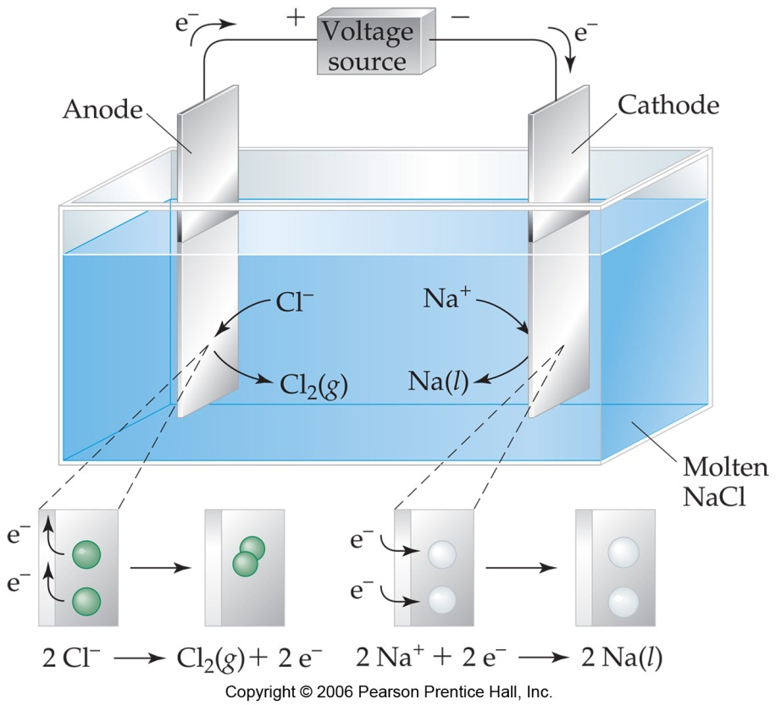

Key Questions
- What process occurs at the anode? Write the anode half reaction.

- What is the sign of the anode (i.e., to what side of the power supply is the anode attached)?

- What process occurs at the cathode? Write the cathode half reaction.

- What is the sign of the cathode in an electrolytic cell?

- Describe the movement of electrons in the electrolytic cell.

- Write the overall balanced equation that takes place in this cell. Include states of matter.

- List two possible materials that can be used as inert electrodes.

- Why does the ionic compound need to be in the liquid state for the electrolysis reaction to proceed?

- State the signs of E_{cell} and ΔG for electrolytic cells.

- Write an overall balanced equation for the electrolysis of the following molten binary salts:
- molten magnesium bromide

- molten aluminum oxide

Part II: Electrolysis in Aqueous Solutions
Predicting the products when electric current is applied to aqueous solutions of ionic compounds is not easily predicted by standard reduction potentials. Often, the voltage required to run an electrolytic cell is higher than the standard reduction potentials would indicate. This higher voltage is referred to as overvoltage, and it is believed to be caused from kinetic effects—electron transfer processes at electrodes interacting with ions in solutions are often quite slow. The overvoltage supplies the activation energy required for the reaction to proceed at a measurable rate.
Additionally, since water is present in these cells, it may also react, which adds another layer of complexity to the process. For each electrode, you need to predict whether the ions from the salt will react or whether water will react. The purpose of this active learning activity is to be able to predict the products of electrolytic cells. As in part I, you may assume that the electrodes are inert and do not participate in the reaction. Generally, electrolysis in aqueous solution is shown as a net ionic equation.

Diagram 2: An electrolytic cell

Key Questions
- Label the anode and the cathode in the diagram above.

- Identify the ionic compound dissolved in the solution. List the cation present. List the anion present.

- Predicting the reduction half-reaction at the cathode:

For the electrolytic cell in diagram 2, the transition metal cation Cu²⁺ will undergo reduction to copper metal at the cathode:
Cu²⁺ + 2 e- → Cu

- Predicting the oxidation half reaction at the anode:

For the electrolytic cell in diagram 2, it is too difficult to oxidize sulfate ion, so instead water is oxidized at the anode to form oxygen gas:
2 H₂O → O₂(g) + 4 H⁺(aq) + 4 e-

To find the overall electrolysis reaction, the two half-reactions are combined:
Anode: 2 H₂O → O₂(g) + 4 H⁺(aq) + 4 e-
Cathode: [Cu²⁺ + 2 e- → Cu] 2

Overall reaction: 2 H₂O + 2 Cu²⁺ → 2 Cu + O₂(g) + 4 H⁺(aq)

Key Questions
- For the cell shown in diagram 2, at which electrode would a gas be released?

- What happens to the pH at the anode for the cell shown in diagram 2? Explain.

- Write net ionic equations for the following electrolysis reactions. Assume that the electrodes are inert.
  - Aqueous sodium chloride

    - What evidence of chemical change would you observe?

    - If phenolphthalein were added to the electrolytic cell as it ran, where would you observe a color change in the cell? Explain

  - Aqueous silver nitrate

  - Aqueous potassium sulfate

  - Aqueous nickel(II) bromide

