Name: _________________________________
Chapter 3 Practice Problems 2022

Multiple Choice
Identify the letter of the choice that best completes the statement or answers the question. Refer to your periodic table and formula sheets.

Work on your mental math skills! Answer the following questions without using a calculator.

____ 1. A compound contains 1.10 mol of K, 0.55 mol of Te, and 1.65 mol of O. What is the simplest formula of this compound?
a. | KTeO | c. | K2TeO3
b. | KTe2O | d. | K2TeO6

____ 2. Which of the following alkali metal chlorides has the lowest percent chloride by mass?
a. | sodium chloride | c. | rubidium chloride
b. | potassium chloride | d. | cesium chloride

____ 3. Which expression gives the percent by mass of carbon in citric acid, C₆H₈O₇•H₂O?
a. | $$\frac{6}{192} × 100$$ | c. | $$\frac{12}{192} × 100$$
b. | $$\frac{12}{210} × 100$$ | d. | $$\frac{72}{210} × 100$$

____ 4. When 8.0 g of N2H4 (32 g mol⁻¹) and 92 g of N2O4 (92 g mol⁻¹) are mixed together and react according to the equation below, what is the maximum mass of H2O that can be produced?
2 N2H4(g) + N2O4(g) → 3 N2(g) + 4 H2O(g)
a. | 9.0 | c. | 36 g
b. | 18 g | d. | 72 g

____ 5. If 0.40 mol of H₂ and 0.15 mol of O₂ were to react as completely as possible to produce H₂O, what mass of reactant would remain?
a. | 0.20 g of H₂ | c. | 3.2 g of O₂
b. | 0.40 g of H₂ | d. | 4.0 g of O₂

The following questions were originally written to be completed without the use of a calculator. First try to select the best answer without a calculator, then check your work with a calculator.

____ 6. Chromium, Cr, can form several oxides, including chromium((II) oxide CrO, chromium(III) oxide, Cr₂O₃, and chromium(VI) oxide, CrO₃. Which oxides of chromium have percent by mass of chromium that is greater than 50%?

a. | CrO, only | c. | CrO and CrO₃
b. | Cr₂O₃, only | d. | CrO, Cr₂O₃, and CrO₃

____ 7. A sample of a solid labelled FeO(s) may be impure. A student analyzes the sample and determines that it contains 31% oxygen by mass. Pure FeO(s) contains 22.3% oxygen by mass. Which of the following statements is consistent with the data?
a. | The sample contains only FeO(s).
b. | The sample contains FeO(s) and MgO(s).
c. | The sample contains FeO(s) and ZnO(s).
d. | The sample contains FeO(s) and CuO(s).

____ 8. M is an unknown metal cation with a +1 charge. A student dissolves the chloride of the unknown metal, MCl, in enough water to make 100. mL of solution. The student then mixes the solution with excess AgNO₃ solution, causing AgCl to precipitate. The student collects the precipitate by filtration, dries it, and records the data shown below. (The molar mass of AgCl is 143.32 g/mol)

Mass of unknown chloride, MCl | 0.5844 g
Mass of filter paper | 0.1000 g
Mass of filter paper plus precipitate | 1.5300 g

Which of the following is the unknown metal cation?
a. | Li | c. | K
b. | Na | d. | Rb

You will need to use a calculator to answer the following questions.

____ 9. A molecule is found to contain 47.35% C, 10.60% H, and 42.05% O. What is the empirical formula for this molecule?
a. | C₂H₆O | c. | C₃H₈O₂
b. | C₃H₄O₂ | d. | C₄H₆O₂

____ 10. When a 1.00–gram sample of limestone was dissolved in acid, 0.38 gram of CO₂ was generated. If the rock contained no carbonate other than CaCO₃, what was the percent of CaCO₃ by mass in the limestone?
a. | 17% | c. | 64%
b. | 51% | d. | 86%

____ 11. What is the mass percent of carbon in dichloromethane, CH₂Cl₂?
a. | 10.06% C | c. | 20.00% C
b. | 14.14% C | d. | 24.10% C

____ 12. How many carbon atoms are contained in 2.8 g of C₂H₄?
a. | 1.2 x 10²³ | c. | 6.0 x 10²³
b. | 3.0 x 10²³ | d. | 1.2 x 10²⁴

Free Response Questions
Calculator use is always permitted for free response questions. You may refer to your periodic table and equation sheets. Show your work, pay attention to significant figures, and report your answer with appropriate units.

2004 B
4 Fe(s) + 3 O2(g) → 2 Fe2O3(s) ΔHf° = -824 kJ mol–1
Iron reacts with oxygen to produce iron(III) oxide as represented above. A 75.0 g sample of Fe(s) is mixed with 11.5 L of O2(g) at 2.66 atm and 298 K.

13. a) Calculate the number of moles of each of the following before the reaction occurs. (2 pts)
(i) Fe(s)
(ii) O2(g)

b) Identify the limiting reactant when the mixture is heated to produce Fe2O3. Support your answer with calculations. (1 pt)

14. A student investigates the reactions of nitrogen oxides. One of the reactions in the investigation requires an equimolar mixture of NO(g) and NO₂(g), which the student produces by using the reaction represented below. (2018)

The particle-level representation of the equimolar mixture of NO(g) and NO₂(g) in the flask at the completion of the reaction between NO(g) and O₂(g) is shown below in the box on the right. In the box below on the left, draw the particle-level representation of the reactant mixture of NO(g) and O₂(g) that would yield the product mixture shown in the box on the right. In your drawing, represent oxygen agoms and nitrogen atoms as indicated below. (2 pts)

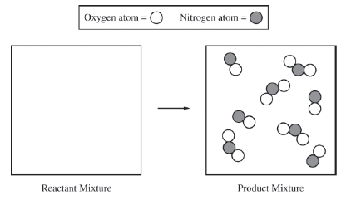

15. Ethene, C₂H₄(g) (molar mass 28.1 g/mol) may be prepared by the dehydration of ethanol, C₂H₅OH(g) (molar mass 46.1 g/mol), using a solid catalyst. A setup for the lab synthesis is shown in the diagram below. (2015)

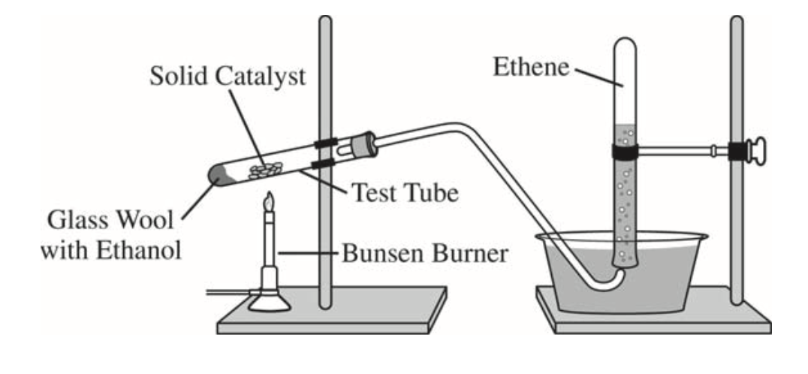

The equation for the dehydration reaction is given below.
A student added a 0.200 g sample of C₂H₅OH(l) to a test tube using the setup shown above. The student heated the test tube gently with a Bunsen burner until all of the C₂H₅OH(l) evaporated gas generation stopped. When the reaction stopped, the volume of collected gas was 0.0854 L at 0.822 atm and 305 K. (The vapor pressure of water at 305 K is 35.7 torr.)

a) Calculate the number of moles of C₂H₄(g)
i) that are actually produced in the experiment and measured in the gas collection tube (2 pts)

ii) and that would be produced if the dehydration reaction went to completion. (1 pt)

b) Calculate the percent yield of C₂H₄(g) in the experiment. (1 pt)

16. A sample of a pure, gaseous hydrocarbon is introduced into a previously evacuated rigid 1.00 L vessel. The pressure of the gas is 0.200 atm at a temperature of 127º C. (2012A)

(a) Calculate the number of moles of the hydrocarbon in the vessel. (2 pts)

(b) O2(g) is introduced into the same vessel containing the hydrocarbon. After the addition of the O2(g), the total pressure of the gas mixture in the vessel is 1.40 atm at 127ºC. Calculate the partial pressure of O2(g) in the vessel. (1 pt)

The mixture of the hydrocarbon and oxygen is sparked so that a complete combustion reaction occurs, producing CO2(g) and H2O(g). The partial pressures of these gases at 127ºC are 0.600 atm for CO2(g) and 0.800 atm for H2O(g). There is O2(g) remaining in the container after the reaction is complete.

(c) Use the partial pressures of CO2(g) and H2O(g) to calculate the partial pressure of the O2(g) consumed in the combustion. (2 pts)

(d) On the basis of your answers above, write the balanced chemical equation for the combustion reaction and determine the formula of the hydrocarbon. (2 pts)

(e) Calculate the mass of the hydrocarbon that was combusted. (2 pts)

Chapter 3 Practice Problems 2022
Answer Section

MULTIPLE CHOICE

1. ANS: C PTS: 1

2. ANS: D PTS: 1 REF: adapted from AP MCQ

3. ANS: D PTS: 1 REF: adapted from AP MCQ

4. ANS: A PTS: 1

5. ANS: A PTS: 1

6. ANS: D PTS: 1 REF: adapted from AP MCQ

7. ANS: B PTS: 1

8. ANS: B PTS: 1

9. ANS: C PTS: 1 OBJ: 3.6 Describing Compound Formulas

10. ANS: D PTS: 1

11. ANS: B PTS: 1 OBJ: 3.6 Describing Compound Formulas

12. ANS: A PTS: 1

PROBLEM

13. ANS:
a) (i) 75.0 g Fe × = 1.34 mol Fe
(ii) PV = nRT, n =
= 1.25 mol O2

b) Fe; 1.34 mol Fe × = 1.01 mol O2
excess O2, limiting reagent is Fe

PTS: 1 KEY: mole; ideal gas law

14. ANS:
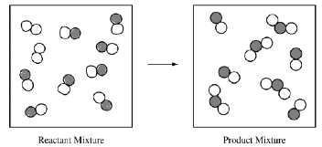
1 pt for representations of NO and O2
1 pt for atom conservation--2 molecules of O2, 8 molecules of NO

PTS: 1

15. ANS:
a) i) Pethene = 0.775 atm, 0.00264 moles of gas
ii) 0.00434 mol

b) 60.8%

PTS: 1

16. ANS:
a) n PV RT { { � �
n = 6.09 x 10-3 moles 1 pt for setup, 1 pt for correct answer

b) PO2 = 1.40 atm – 0.200 atm = 1.20 atm 1 pt for correct answer

c) PO2 = 1.000 atm, based on stoichiometry OR ideal gas law 1 pt for stoichiometry/work, 1 pt for correct answer

d) C3H8 + 5O2 --> 3CO2 + 4H2O 1 pt for correct hydrocarbon (can be found from relative partial presssure ratios OR from calculating empirical formula) 1 pt for correct equation

e) .269 g 1 pt for using moles from part a, 1 pt for correctly finding mass with gfm

PTS: 1

