Determining the Molar Enthalpy  
of Solution

Dissolving salts in water involves an exchange of heat energy; in some cases, the heat transfer can be quite dramatic! This heat transfer is called the enthalpy of solution, ΔHsoln. ΔHsoln may be endothermic or exothermic, depending on two factors:

1. the energy required in breaking the bonds of the crystal lattice into its ions (endothermic)
2. the energy released when the ions are attracted to water molecules (exothermic)

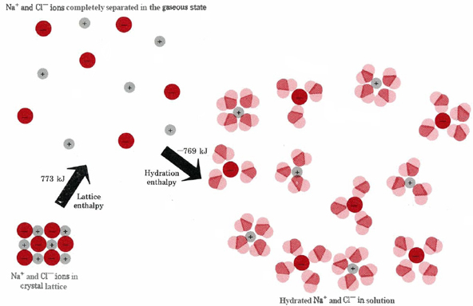Figure 1 below shows the process for sodium chloride:

Figure 1: The energetics of the solution process for sodium chloride

Source: Chem Education Digital Library

This can also be represented as an enthalpy diagram, as shown in Figure 2:

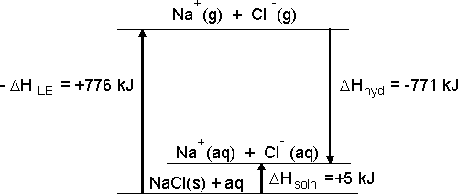

Figure 2: An enthalpy diagram for dissolving sodium chloride in water

The value of the enthalpy of solution can be positive, as shown for sodium chloride in Figure 2, or it can be negative. It is generally not possible to directly measure the heat energy change of the reactants and products (the system). We can measure the heat change that occurs in the surroundings by monitoring temperature changes. If we conduct a reaction between two substances in aqueous solution, then the enthalpy of the solution can be indirectly calculated with the following equation.

*Q* = *C*× *m* × ∆*T*

The term *q* represents the heat energy that is gained or lost. *C* is the specific heat of water, *m* is the mass of the solution, and ∆*T* is the temperature change of the reaction mixture. The specific heat and mass of water are used because water will either gain or lose heat energy in a reaction that occurs in aqueous solution.

If solutes absorb energy from the water as they dissolve, the water gets colder and the solution process is endothermic. If solutes release energy to the water as they dissolve, the water gets warmer and the solution process is exothermic. It is possible to determine the enthalpy per mole of salt dissolved using this data. We assume that the enthalpy change for the solution is equal in magnitude to the change in heat for the water (Q), but the sign is opposite: H = -Q.

In this experiment, you will carry out an experiment to determine the enthalpy of solution, Δ*Hsoln/mol* of a solid. You will use two Styrofoam cups nested in a beaker as a calorimeter, as shown in Figure 3. For purposes of this experiment, you may assume that the heat loss to the calorimeter and the surrounding air is negligible.

Figure 3

OBJECTIVE

In this experiment, you will

* Experimentally determine the molar enthalpy of solution for two salts

MATERIALS

|  |  |
| --- | --- |
| LabPro or CBL 2 interface  ring stand |  |
| Thermometer or Temperature Probe  Distilled water  Weighing paper or boats  400 mL beaker  glass stirring rod | One of the following: sodium acetate trihydrate OR ammonium chloride  One of the following: lithium nitrate OR ammonium acetate |

PROCEDURE

1. Set up your calorimeter by stacking the two styrofoam cups inside each other, and then placing the cups inside the 400 mL beaker.
2. Measure about 80 mL of distilled water. Record the precise volume in your data table. Transfer the water to the calorimeter.
3. Find the mass of about 10 g of one of the solids you selected. Record the precise mass in your data table. Record observations about the solid.
4. Record the initial temperature of the water. Record the precise temperature in your data table.
5. Dissolve the solid in the water. Stir with the stirring rod.
6. Record the maximum (or minimum) temperature of the water.
7. Rinse out the calorimeter, dry it thoroughly, and repeat steps 2-6 with the second solid you chose.

Observations:

Data:

|  |  |  |  |  |
| --- | --- | --- | --- | --- |
| Substance | volume water used (mL) | mass of solute used (g) | initial water temperature (oC) | final water temperature (oC) |
|  |  |  |  |  |
|  |  |  |  |  |

Calculations: Show all your work.

1. For each of the solutes, calculate the change in temperature (DT) of the water.
2. Calculate the mass of the water in the calorimeter in each trial. The density of water at
3. Calculate the change in energy (Q) of the water in each trial. Use the total mass of the solution. Assume that the specific heat of the solution is the same as the specific heat of water.
4. Calculate the number of moles of each solute that you used.
5. Calculate the experimental molar enthalpy of solution, in kJ/mol, for each solute. Pay attention to the sign conventions!
6. Calculate the percent error for each trial. You can find the [accepted values of the molar enthalpies of solution online](https://diverdi.colostate.edu/C433/miscellanea/CRC%20reference%20data/enthalpies%20of%20solution%20of%20electrolytes.pdf)

**ANALZYE AND APPLY**

1. For which salt was the dissolving process endothermic? For which salt was the dissolving process exothermicExplain how you determined this.
2. What measurement(s) limited your precision in this experiment? Explain.
3. What were the most likely sources of error in your experiment, and how did they affect your experimental molar enthalpy?
4. If you were to repeat your experiment, what improvements would you make in order to get better accuracy and/or precision? Be specific!