AP Chemistry
Electron Configurations

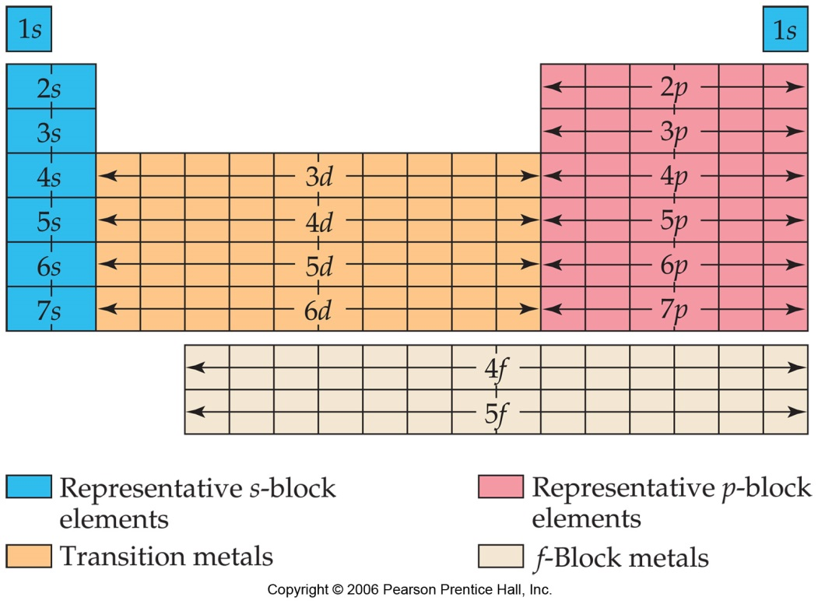
Summarize the three rules for writing electron configurations:
- Aufbau principle

- Pauli Exclusion Principle

- Hund’s Rule

Phosphorus
Orbital notation (arrows and boxes)

Spectroscopic notation | Noble gas notation
Number of valence electrons:

- Iron
Orbital notation (arrows and boxes)

Spectroscopic notation | Noble gas notation
Number of valence electrons:

- Gallium
Orbital notation (arrows and boxes)

Spectroscopic notation | Noble gas notation
Number of valence electrons:
Exceptional Electron Configurations…be aware of the patterns, no need to memorize!
- Group 6: ns¹ (n-1)d⁵ The spherically symmetric electron distribution of d⁵ has fewer electron-electron repulsions and therefore is lower in energy than the predicted configuration
- Group 12 ns¹ (n-1)d¹⁰ with similar reasoning as above…having all the d orbitals filled completely with a half-filled s orbital minimizes repulsions
- Lanthanides and actinides are often d¹ s² or have unoccupied d sublevels, “promoting” electrons into the f sublevel

Valence electrons
  - Electrons in fully filled d and f orbitals are NOT considered to be valence electrons
  - However, electrons in partially filled d orbitals are considered to be valence electrons!
    - Strictly speaking, d block elements follow the 18-electron rule, not the octet rule

