AP Chemistry: Intermolecular Attractions Problem Set Part 2

Discuss and compare answers with your classmates. Working asynchronously today? Consider setting up a Zoom session with another AP Chem student!

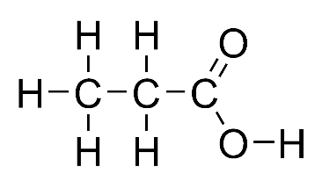 |  | 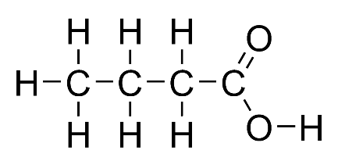
Propanoic acid |  | Butanoic acid
1. Shown above are the Lewis structures for propanoic acid and butanoic acid. Propanoic acid has a lower boiling point than butanoic acid.
- Identify all intermolecular forces present in each molecule.

- Which intermolecular force is most responsible for the difference in boiling point?

- Two types of intermolecular forces present in liquid H₂S are London (dispersion) forces and dipole-dipole forces.
  - Compare the strength of the London (dispersion) forces in liquid H₂S to the strength of the London (dispersion) forces in liquid H₂O. Explain.

b. Compare the strength of the dipole-dipole forces in liquid H₂S to the strength of the dipole-dipole forces in liquid H₂O. Explain.

3. Use the information in the table below to answer the questions that follow about three organic compounds.

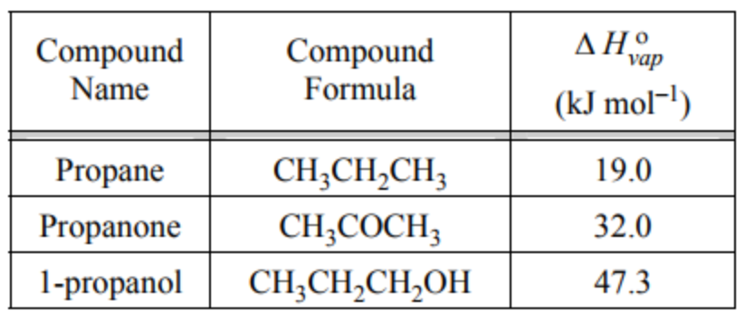

a. Explain why propane has a smaller heat of vaporization than propanone.

b. Explain why propanone has a smaller heat of vaporization than 1-propanol.

4. Which of the figures below correctly shows a hydrogen bond? Explain your reasoning.

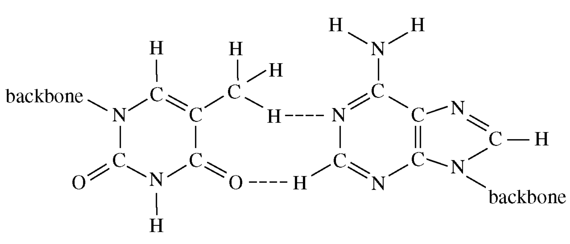 |  | 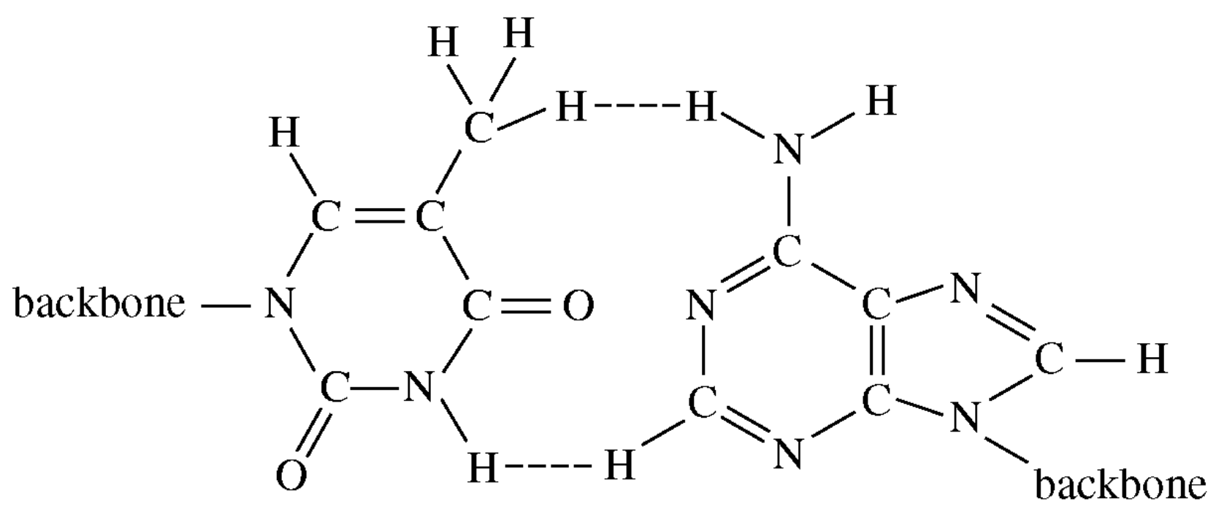
Figure A |  | Figure B
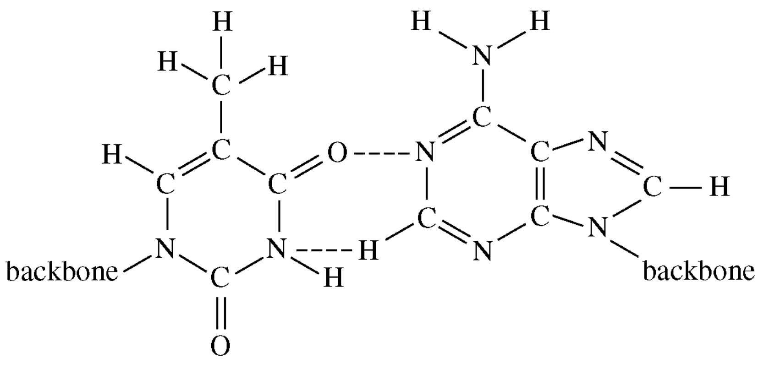 |  | 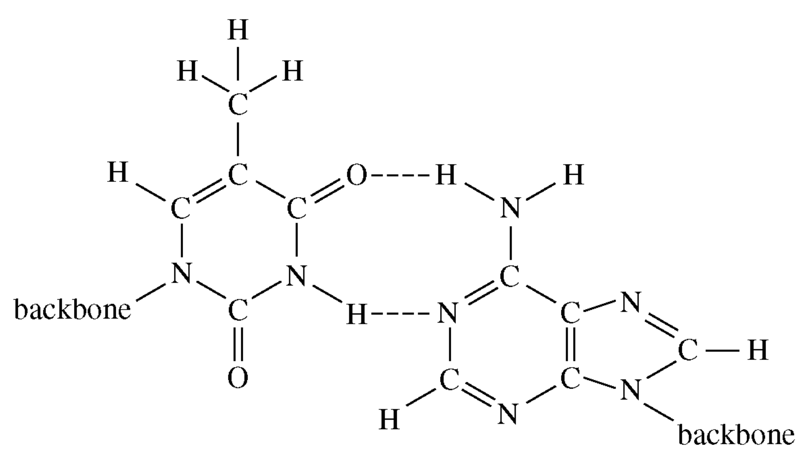
Figure C |  | Figure D

5. Shown below is a molecule of urea (H₂NCONH₂), which is highly soluble in water. Draw and label the hydrogen bonds between urea and water.

