NAME: HONORS CHEMISTRY
SECTION: Gases Review Sheet

After studying this unit, you should be able to:
- Describe the motion of particles of substances in the three common states of matter in terms of the kinetic theory and bonding in the substances.
- Relate that the temperature of a substance is a measure of the kinetic energy of the particles in that substance.
- Distinguish between real and ideal gases.
- Interpret gas pressure in terms of kinetic theory.
- Determine the pressure of a confined gas using open and closed manometers.
- Convert between different units of pressure.
- Explain, using kinetic theory, why molecules of small mass diffuse more rapidly than molecules of large mass.
- Determine the relative velocities of gas molecules at the same temperature.
- Calculate pressure or volume from the pressure-volume relationship of a contained gas at constant temperature.
- Calculate temperature or volume from the temperature-volume relationship of a contained gas at constant pressure.
- Calculate temperature or pressure from the temperature-pressure relationship of a contained gas at constant volume.
- Calculate pressure, volume, or temperature from the temperature-pressure-volume relationships of confined gases.
- Calculate the total pressure of a mixture of gases or the partial pressure of a gas in a mixture of gases.
- Calculate the amount of gas at any specified conditions of pressure, volume, and temperature.
- Calculate the volume of gas formed from a reaction at both standard and non-standard conditions.

- Under what conditions will real (i.e, non-ideal) gas behavior be likely?

- Why can gases be compressed more easily than solids or liquids?

- Read the following manometers.

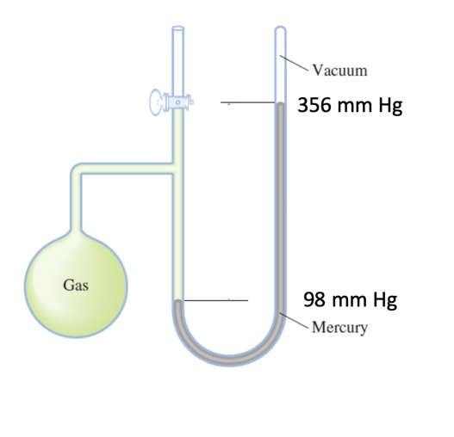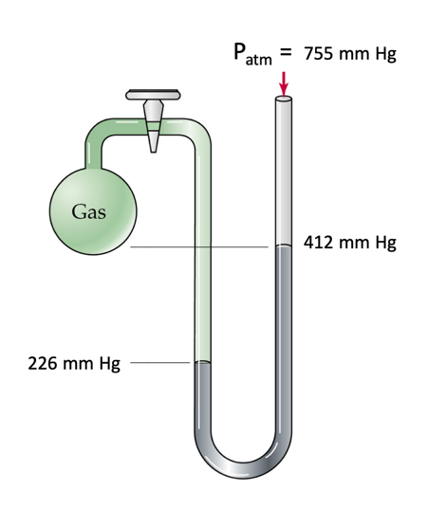

- A sample of oxygen gas is collected over water.
  - What is meant by the vapor pressure of water?

  - How does the vapor pressure of water affect the observed pressure of a gas collected over water?

  - How can you determine the actual pressure of the oxygen obtained? Why must you know the temperature at which the gas was collected?

- 7.83 L of a gas were collected over water at 20ºC and 107 kPa. Determine the volume that the dry gas would occupy at standard pressure. Assume temperature is constant. (See Table 13.2 on p. 428 in your textbook.)

- Hydrogen and oxygen are easily collected over water. However, it is not advisable to try to collect carbon dioxide or hydrogen chloride by this method. Can you suggest a reason why?

- What pressure will be exerted by each of the gases in the following mixture if the total pressure of the mixture amounts to 768.8 torr? 0.500 g of hydrogen; .245 g of oxygen; .335 g of nitrogen

- A dry gas at a temperature of 18.0ºC has a volume of 40.0 mL. What temperature change is needed to reduce this volume to 35.0 mL?

- The volume of a gas at a pressure of 90.0 kPa is doubled and the temperature remains constant. What is the final pressure exerted by the gas?

- A weather balloon is filled with 1.0L of helium at 23ºC and 1.0 atm. What volume does the balloon have when it has risen to a point in the atmosphere where the pressure is 220 torr and the temperature is -31ºC?

- A balloon will burst at a volume of 2.0 L. If the gas in a partially filled balloon occupies 750 mL at a temperature of 21ºC and a pressure of 9.90 x 10⁴ Pa, what is the temperature at which it will burst if the pressure is 1.01 x 10⁵ Pa at the time it breaks?

- If the density of oxygen is 0.00143 g/mL at STP, what is the density of oxygen at 99.0 kPa and 27.0ºC?

- How do diffusion and effusion differ?

- Use an example to explain Graham’s Law.

- What is the ratio of the speed of hydrogen molecules to the speed of neon atoms when both gases are at the same temperature and pressure?

- At a certain temperature, the velocity of chlorine molecules, Cl₂, is 0.0410 m/s. What is the velocity of sulfur dioxide molecules, SO₂, at the same temperature and pressure?

- The relative rate of diffusion between two gases is 1.89. If the lighter gas is methane (16 g/mol), what is the molar mass of the other gas?

- A sample of gas has a mass of 1.248 g and occupies 300.0 mL at STP. What is the molar mass of this gas?

- How many grams of ammonium sulfate must react with excess sodium hydroxide to produce 408 mL of ammonia measured at 27ºC and 98.0 kPa? Start with a balanced equation!

- What volume of hydrogen collected over water at 27ºC and 97.5 kPa is produced by the reaction of 3.00g of Zn with an excess of sulfuric acid? Start with a balanced equation!
(The vapor pressure of water at 27ºC is 3.6 kPa.)
Answers to selected problems
5. 8.09L
7. P_{H2} = 711 torr;
P_{O2} = 22 torr;
P_{N2} = 34 torr
8. a 37ºC temperature decrease
9. 45.0 kPa
10. 2.8L
11. 8.0 x 10² K,
or 527ºC
12. 0.00127 g/mL
15. 3.16:1
16. 0.0421 m/s
17. 57 g/mol
18. 93.2 g/mol
19. 1.06 g e
20. 1.22 L H₂

