NAME: HONORS CHEMISTRY
SECTION: Atomic Emission Spectra of Elements

1. Sketch in the visible light spectrum at
http://media.web.britannica.com/eb-media/30/27030-004-293E0372.jpg
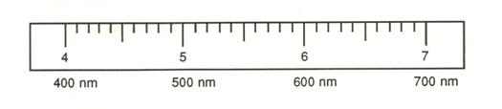
2. Go to http://physics.bu.edu/~duffy/HTML5/emission_spectra.html Using colored pencils or crayons, sketch the bright line emission spectra of the following elements: (just show the general position of the bright line and don’t worry about exact positioning of the lines or the background)
H
He
Li
Na
Hg

Answer the following questions: (Refer to your notes and pp. 326-331 in your textbook.)

3. Summarize the relationship between wavelength of light and the energy of its photon:

4. What are photons?

5. What is meant by the wave-particle nature of light?

6. Explain the difference between continuous energy levels vs. quantized (discrete) energy levels.

7. What is the ground state of an atom? What is an excited state of an atom?

8. List the key features of the Bohr model of the atom. Include a sketch.

9. What are the limitations of Bohr's model of the atom?

