NAME: HONORS CHEMISTRY
SECTION: Webquest: Developing Atomic Theory

Use the links provided, as well as information available in your textbook, to answer the following questions. Answer the questions in complete sentences and complete this assignment in Google Classroom.

The following websites provide general timelines for many milestones in physics/chemistry. These include the important people, dates and discoveries in the development of the atomic theory.
http://www-donut.fnal.gov/web_pages/standardmodelpg/TheStandardModel.html
https://www.infoplease.com/math-science/physics/atomic-theory
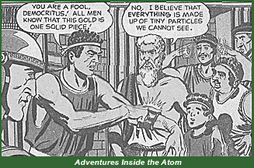
http://cstl-csm.semo.edu/cwmcgowan/ch181/atomhist.htm

Part I: Ancient Greek Philosophers
Links:
- http://www.particleadventure.org/other/history/
- https://plato.stanford.edu/entries/chemistry/ Scroll down to sections 1.1 and 2.1
- http://www.chm.bris.ac.uk/webprojects2002/tubb/elements.htm
- http://www-history.mcs.st-and.ac.uk/history/Biographies/Democritus.html

Questions
- According to the ancient Greeks, what are the four main types of elements?

- According to Democritus (“the laughing philosopher”), what is the composition of matter?

- What is the root of our word “atom” and why is it misleading?

- Identify some other Greek philosophers (at least 2) who also studied matter. Briefly summarize their main ideas about matter.

- Whose theory of matter survived the golden age of Greece and became the accepted authority until the 19th century? Why was this philosopher’s work pre-eminent during this time frame?
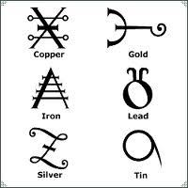

Part II: Alchemy
Links:
- http://www.chm.bris.ac.uk/webprojects2002/crabb/history.html
- Virtual alchemy workshop at http://www.chm.bris.ac.uk/webprojects2002/crabb/flash.html (uses Flash, may not run on MacBook)
- https://www.discovermagazine.com/the-sciences/isaac-newton-worlds-most-famous-alchemist
- http://public.wsu.edu/~delahoyd/medieval/alchemy.html

Questions
- List at least 3 famous alchemists and a major accomplishment for each.
Some alchemical symbols
- List at least three regions of the world where alchemy was pursued.

- What two main classes of interests did the European alchemists have?

Part III: Developing a Rational Theory

Joseph Proust
Links
- http://www.3rd1000.com/history/atoms.htm
- http://www.chemteam.info/AtomicStructure/LawofDefiniteProportion.html
- http://web.lemoyne.edu/~giunta/proust.html

Questions
- What famous law is attributed to Proust? Summarize the law in your own words.

- Was this law initially accepted or challenged? How was it eventually settled?

Antoine Lavoisier
Links
- http://scienceworld.wolfram.com/biography/Lavoisier.html
- http://mattson.creighton.edu/History_Gas_Chemistry/Lavoisier.html
- http://www.historylearningsite.co.uk/antoine_lavoisier.htm

Questions
- What famous law is attributed to Lavoisier?

- Why is Lavoisier called the “father of modern chemistry”?

- List 3 of Lavoisier’s other accomplishments (beyond your answer to question #11).

John Dalton
Links
- http://www-donut.fnal.gov/web_pages/standardmodelpg/TheStandardModel.html
- http://www.3rd1000.com/history/atoms.htm
Dalton’s chemical symbols
- http://northspringer.tripod.com/HistoryofAtom/id1.html
- https://www.chemheritage.org/historical-profile/john-dalton
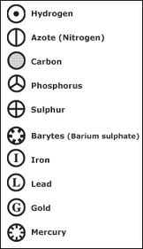
Questions
- What were the 5 key statements (postulates) of Dalton’s atomic theory?

- Why was Dalton’s theory a modern theory? (Hint: What did Dalton do, that the ancient Greek philosophers never did?)

- What elements of the Greek theory/model did Dalton retain?

- List some of Dalton’s other scientific interests.

