NAME: HONORS CHEMISTRY
SECTION: Equilibrium practice problems

You should be able to:
- Define chemical equilibrium.
- Explain the nature of the equilibrium constant.
- Write chemical equilibrium expressions and carry out calculations involving them.
- Discuss the factors that disturb equilibrium.
- Use LeChatelier’s principle to explain the effects of stresses on system equilibrium.
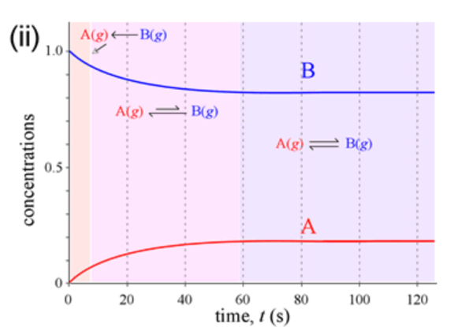
- Consider the graph below.
- At what time is equilibrium established? How do you know?

- At equilibrium, are reactants or products favored? How do you know?

- Explain how to write an equilibrium constant expression. Write a K_{eq} for a reaction of your choice, which should include at least one substance that is a solid or pure liquid.

- For each of the following values for K_{eq}, determine whether the reactants or products will be favored.

- K_{eq} = 2.66 x 10⁴

- K_{eq} = 3.4

- K_{eq} = 5.772 x 10⁻¹³

d) K_{eq} = 1.00

- Consider the reaction: 2 SO₃(g) ⇌ 2 SO₂(g) + O₂(g)
- Write an equilibrium constant expression for this reaction.
- Calculate K_{eq} for this reaction if the equilibrium concentrations are: [SO₂] = 0.42 M, [O₂] = .21 M, [SO₃] = 0.072 M
- Are reactants or products favored at equilibrium?

- Consider the reaction: COCl₂(g) ⇌ CO(g) + Cl₂(g) which has a K_{eq} = 170 at 25ºC.
- Write an equilibrium constant expression for this reaction.

- If the concentrations of CO and Cl₂ are each 0.15 M, what is the concentration of COCl₂ at equilibrium?

- At 25ºC, the following reaction has an equilibrium constant of 9.0 x 10⁻⁴. First, write an equilibrium constant expression. Then find the concentration of A(g) in moles/L, when the concentration of B(g) is 0.03 M and the concentration of C(g) is 0.06 M.

A(g) + D(s) ⇌ B(g) + 2 C(g)

- State LeChatelier’s principle.

- Explain how the equilibrium position of this reaction is affected by the following changes:
4 HCl(g) + O₂(g) ⇌ 2 Cl₂(g) + 2 H₂O(g)

a. add Cl₂
b. remove O₂
c. increase pressure
d. use a catalyst

- Which of the following stresses will change the value of the equilibrium constant?
a. adding reactants
b. removing products
c. increasing the temperature
d. increasing the volume
e. decreasing the temperature

- Consider the equilibrium equation for the reaction:
4 HCl(g) + O₂(g) + heat ⇌ 2 Cl₂(g) + 2 H₂O(g)
- If the temperature of the system is increased, how will the equilibrium shift?

- If the pressure on the system is increased, how will the equilibrium shift?

c) If additional water vapor is added to the system, how will the system respond?

d) If neon gas is added to the system, how will the system respond?

Additional practice: http://chemistry2.csudh.edu/homework/hwintro.html
#74, 75, 76
Answers to selected problems
1a. ~60 seconds, because the concentrations stop changing at that time
5b. Keq = 7.1
6. [A] = 0.1M
8a. shift left
9. choices c and e
10a. shift right
10d. no shift

