INTERMOLECULAR FORCES FOLDABLE

Directions:
Fold a piece of paper in half the long way.
Make four cuts to the fold, making 5 flaps.
Label the outside of each flap (1 label per flap):
Ion-dipole attraction Dipole-dipole attraction
Hydrogen bond London forces
Dipole-induced dipole attractions

Cut out the boxes below.
On the back of each flap, attach the written description that correctly describes that intermolecular attraction. On the inside, attach the visual that corresponds to that type of intermolecular attraction.
When you are done, glue your foldable into your notebook.

Two polar molecules interact with oppositely charged regions attracted | The presence of a permanent dipole induces a temporary dipole in a nonpolar species | A hydrogen atom bonded to N, O or F is bonded to another molecule’s N, O or F atom |  | Two nonpolar species are temporarily attracted to each other when induced dipoles form | An ion attracts the oppositely charged region of a polar molecule
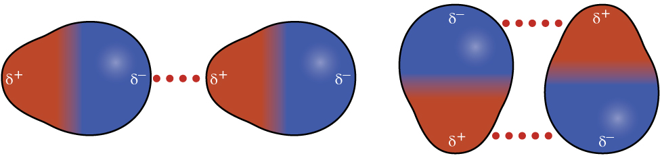 |  |  | 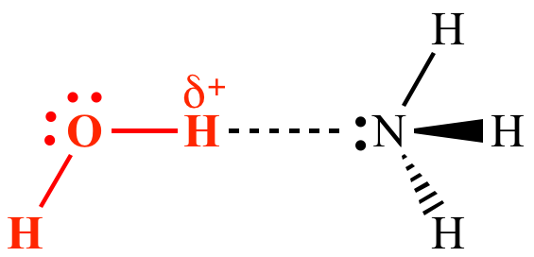
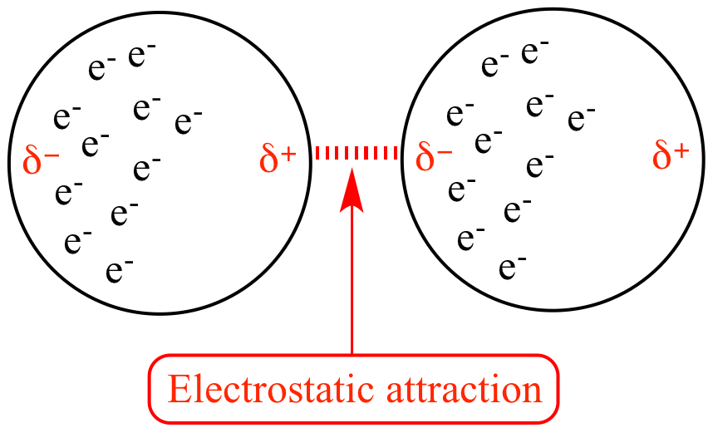 |  |  | 