NAME: HONORS CHEMISTRY
SECTION: Rate Expressions and Reaction Rates

Refer to your notes from the podcast while you answer these questions!

Monitoring Reactions

- Consider the reaction between aqueous copper(II) chloride and aqueous lead(II) nitrate:
CuCl₂(aq) + Pb(NO₃)₂(aq) Cu(NO₃)₂(aq) + PbCl₂(s)
What property of the reaction could most easily be monitored to determine the rate of reaction?

- Chromium metal displaces hydrogen from hydrochloric acid:
2Cr(s) + 6 HCl(aq) 2 CrCl₃(aq) + 3 H₂(g)
- List two methods for monitoring the progress of this reaction.

- What else needs to be measured to determine the reaction rate?

- Write a rate expression for this reaction in terms of the disappearance of hydrochloric acid.

- Write a rate expression for this reaction in terms of the appearance of hydrogen gas.

- Consider the reaction that occurs when nitrogen dioxide is dissolved in water:
3NO₂(g) + H₂O(l) 2 HNO₃(l) + NO(g)
If NO gas is produced at a rate of 1.5 mol/min, at what rate does NO₂(g) disappear? Show your work or explain how you arrived at your answer.

- Using Concentration vs. Time Graphs
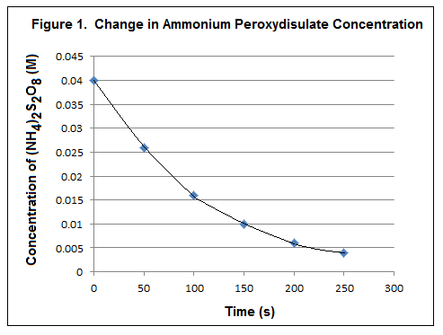
Use Figure 1 to answer questions 4-8.
- Is (NH₄)S₂O₈ a reactant or a product? Justify your answer.

- What happens to the rate of reaction over time? Explain.

- Calculate the initial rate of change in concentration of (NH₄)S₂O₈ in M/s. Show your work.

- Calculate the average rate of change in concentration of (NH₄)S₂O₈ between t = 50 s and t = 150 s. Show your work.

- Explain how to calculate the instantaneous rate of change in concentration of at t = 100 s. Show the necessary work.

- Collision Theory
- Use figures 2 and 3 below to determine the temperature at which the reaction rate will be faster. Explain your reasoning.
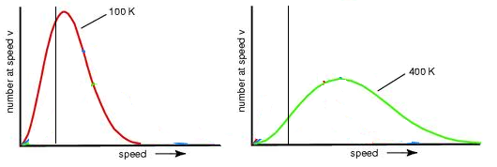
E_{a}
E_{a}
Figure 2—Energy distribution at 100K Figure 3—Energy distribution at 400K

