NAME: HONORS CHEMISTRY
SECTION: Particle and Mole Conversions

State Avogadro's number:

The Mole Road:
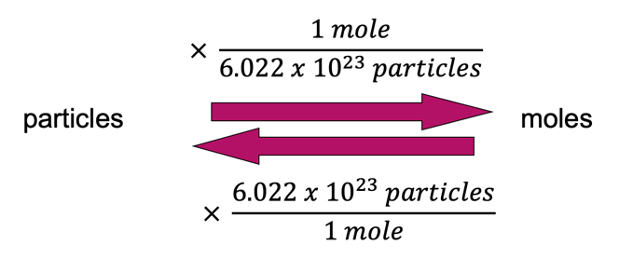

Complete the following problems. Use factor label and show your work.

- How many atoms are present in a 0.112 mol sample of rhenium?

- Calculate the number of molecules present in a 5.3 mol sample of water, H₂O.

- How many moles are present in a sample containing 9.47 x 10²³ atoms of neon?

- A sample consists of 1.45 x 10²² molecules of benzene, C₆H₆. How many moles of benzene are present?

- Calculate the number of carbon atoms present in a 0.57 mol sample of glucose, C₆H₁₂O₆.

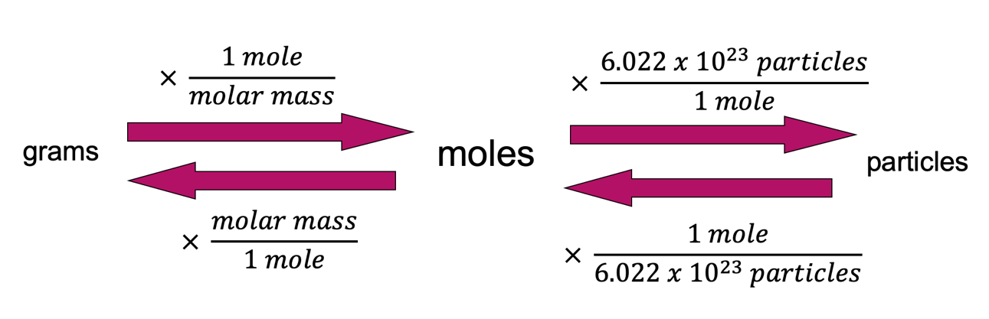

- Calculate the mass of a sample of aluminum which contains 5.55 x 10²³ atoms of aluminum.

- A sample of helium gas has a mass of 14.7 g. How many atoms of helium are present in the sample?

