NAME: HONORS CHEMISTRY
SECTION: Reaction Kinetics Mixed Practice

- Using collision theory described in this unit, explain the following observations:
- Sugar dissolves faster in a cup of hot coffee than in cold lemonade.

- A sugar cube dissolves more slowly than granulated sugar.

- Stirring a teaspoon of sugar helps it dissolve faster than not stirring it.

2. Draw the potential energy diagram for the following reaction.

PE of reactants = 250 kJ
PE of activated complex = 350 kJ
PE of the products = 300 kJ

a) Is the forward reaction exothermic or endothermic?

b) What is the value of ΔH? Include the correct sign

c) What is the activation energy for the forward reaction?

d) What is the activation energy for the reverse reaction?

If a catalyst was added, what would happen to the energies of the:
e) Reactants? __________________
f) Products? _________________
g) Activated Complex?_________________
h) If a catalyst was added, what would happen to the rate? _________________
i) Indicate on your graph how the PE diagram would change if a catalyst were added.

3. Given the reaction:
4HBr + O₂ → 2H₂O + 2Br₂
- Would you expect this reaction to take place in a single step? Why or why not?

This reaction is thought to take place by means of the following mechanism:
Step 1: HBr + O₂ → HOOBr (slow)
Step 2: HBr + HOOBr → 2HOBr (fast)
Step 3: 2HBr + 2HOBr → 2H₂O + 2Br₂ (fast)

- Identify the two intermediates. ________________________________________________

- Which step is the rate determining step in this mechanism? ________________________

d) A catalyst is discovered which increases the rate of Step 3. How will this affect the rate
of the overall reaction? Explain.

e) A catalyst is discovered which increases the rate of Step 1. How will this affect the rate
of the overall reaction? Explain.

f) Which step has the greatest activation energy? _____________________________

g) How many "bumps" will the potential energy diagram for the reaction mechanism have?

h) In order to have successful collisions, the colliding particles must have both the proper
amount of energy and the proper _________________________________________________.

i) On the set of axes below, draw the shape of the curve you might expect for the reaction
in this question. The overall reaction is exothermic! Make sure you get the "bumps" the
correct relative sizes.
PE

Reaction progress

4. At 20ºC, a 3% solution of hydrogen peroxide produces 15 mL of oxygen gas in 120 seconds. What is
the rate of this reaction? Include appropriate units and show your work.

5. A large quantity of 1.0M nitric acid was added to a 5.0 g sample of marble powder in an evaporating dish, which was placed on the pan of a balance. A chemical reaction occurred, forming calcium nitrate, carbon dioxide, and water. The mass of the dish and its contents was recorded every half minute. The results are shown in the graph below.
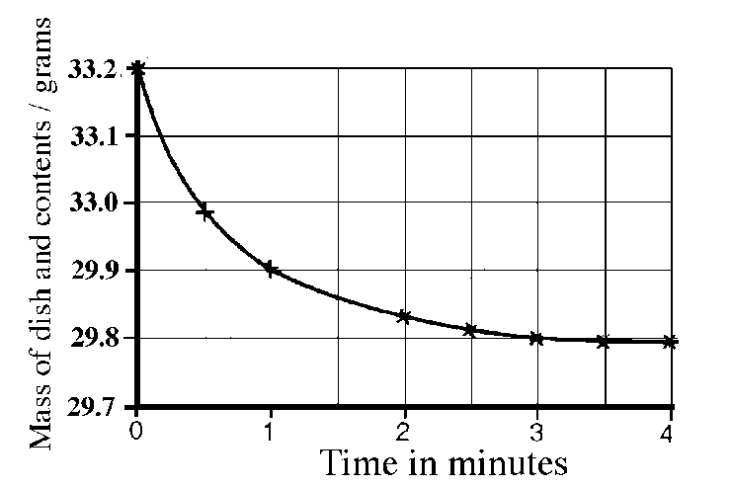
a) Using the data in the graph, calculate the average rate of the disappearance of gaseous products between one and three minutes.

b) Suppose 6.0 M nitric acid is substituted for the 1.0M acid. Predict whether the new rate will be faster or slower than your answer from part (a). Explain your answer in terms of collision theory.

